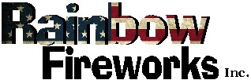

Display Operators Safety Certification School
Oklahoma Law require all shooters to undergo a permitting process.
A Pyrotechnic Safety School will be offered at:
Pawnee Nation Fire Department
301 Agency Rd
Pawnee, Oklahoma 74058

on Saturday, March 4, 2023
Sign in starts at 8:45am
Class is from 9:00am to 5:00pm

Pre-registration is requested. THERE IS NO COST! Lunch will be provided.
This class covers the necessary classroom education & hands-on training for both new and renewal licenses. Attendees will receive a certificate of completion which is necessary to complete the OK State Fire Marshal Application for Outdoor Display Operator License.
For more information, please contact Karen
at 620-663-7714 or karen@fireworks-display.com

76 Plum Avenue Inman, Kansas USA 67546-8670
Office: 1-620-663-7714 Toll Free: 1-888-886-1008 Fax: 1-800-884-1218
info@fireworks-display.com www.fireworks-display.com

